Social impact or Business impact:

Social impact:

India Population growth Infrastructure:

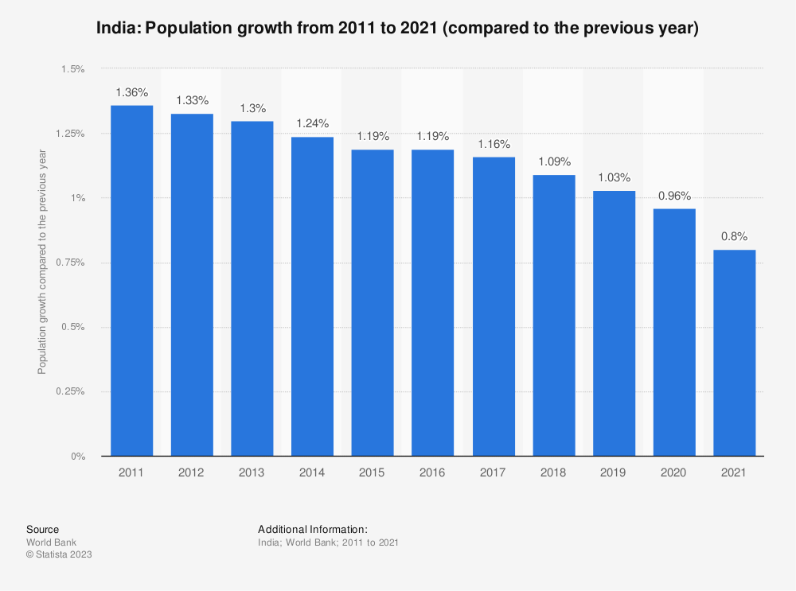

Business Model On growth population:

Companies use demographics in four primary ways to help them create an effective marketing plan.

Social media marketing: Study social media platforms’ key demographics to determine on which platforms your target audiences are likely to be active and readily available. Pew’s Social Media Fact Sheet discusses platform use by demographics.

Ad spend: Websites, radio stations and email newsletters also generally publish demographic breakdowns of their audiences. Use their media packs to determine which advertising platforms will likely generate the highest return on investment.

Marketing campaign images: Strong branding is more important than ever, and by understanding the demographic makeup of your audience, you can decide how to address your target clients both linguistically and visually. This should form part of your buyer personas, which we will cover later.

Ad and marketing image placement: Would you place ads for a product with a mostly rural consumer base in subway stations or on the sides of buses? That’s why so many public transit ads are for movies or apps – people living in urban areas tend to use these products and services more than rural residents do.